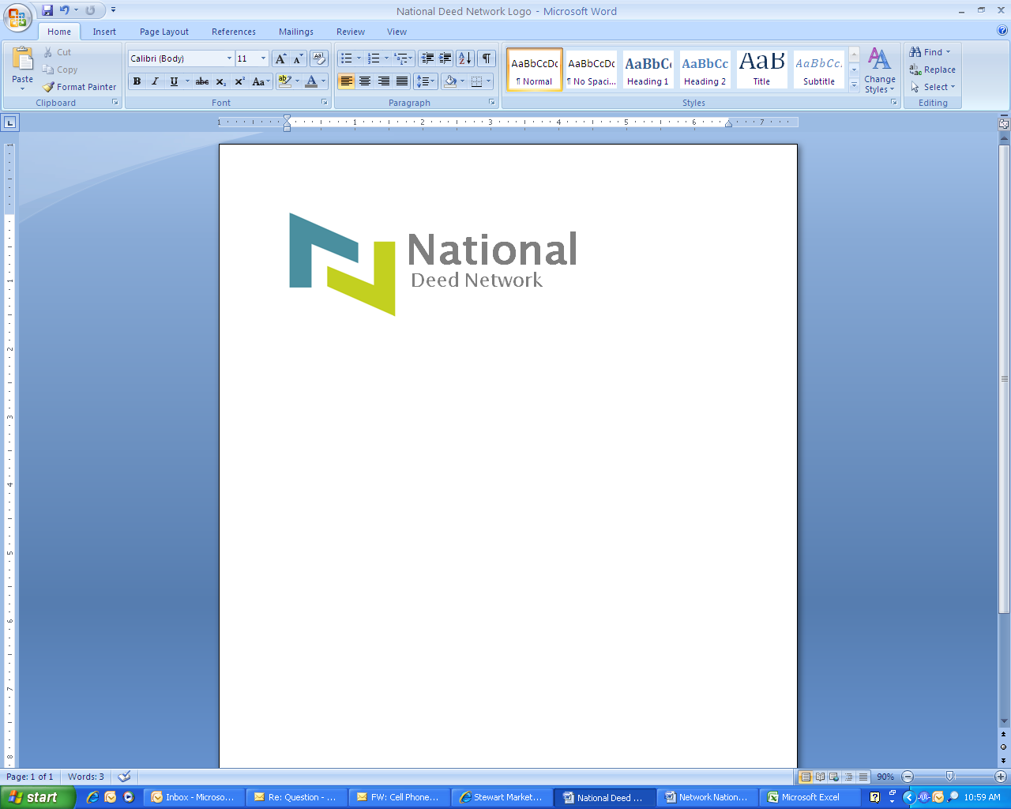
24500 US HWY 19 N, Suite 236, Clearwater, Florida 33763
Telephone: 1-866-234-4529 / Facsimile: (727) 793-6758
orders@nationaldeednetwork.com

Your Name: |  |  |  |  | Phone Number: |  |  |  | Ext:
Your E-mail Address: |  |  |  |  |  |  | Deal No.:
Today’s Date:

ITEMS NEEDED: Title Commitment, Last Deed of Record; Seller’s and Buyers’ Marital Status, Legal Description.

DEED TYPE: |  | Quit Claim Deed |  |  | Deed of Gift (Virginia only)
 |  | General Warranty Deed |  |  | Interspousal Deed (California only)
 |  | Grant, Bargain & Sale (Nevada) |  |  | Corrective Deed
 |  | Disclaimer Deed (Arizona) |  |  | Grant Deed (California only)
 |  | New Mexico Sole & Separate Agreement |  |  | Other [please specify]

CURRENT OWNER INFORMATION:
(as it appears on last deed of record)
GRANTOR / CURRENT VESTING:
Mailing Address:
Current Marital Status of Grantor 1: (check one if applicable) |  |  |  |  | SINGLE |  | MARRIED |  | DIVORCED |  | WIDOW or WIDOWER
Current Marital Status of Grantor 2: (check one if applicable) |  |  |  |  | SINGLE |  | MARRIED |  | DIVORCED |  | WIDOW or WIDOWER
Current Marital Status of Grantor 3: (check one if applicable) |  |  |  |  | SINGLE |  | MARRIED |  | DIVORCED |  | WIDOW or WIDOWER
Grantor relationship to Grantee, if any:

PROPERTY ADDRESS:

Street: |  | City, State, Zip:

County where property is located:

NEW OWNER INFORMATION:
GRANTEE /
NEW VESTING:
Mailing Address:
Current Marital Status of Grantee 1: (check one if applicable) |  |  |  |  |  |  |  |  |  | SINGLE |  |  | MARRIED |  |  |  | DIVORCED |  | WIDOW or WIDOWER
Current Marital Status of Grantee 2: (check one if applicable) |  |  |  |  |  |  |  |  |  | SINGLE |  |  | MARRIED |  |  |  | DIVORCED |  | WIDOW or WIDOWER
Current Marital Status of Grantee 3: (check one if applicable) |  |  |  |  |  |  |  |  |  | SINGLE |  |  | MARRIED |  |  |  | DIVORCED |  | WIDOW or WIDOWER
Vesting Options: (check one) |  |  |  |  | None or  NOT APPLICABLE |  |  |  |  | JOINT TENANCY |  |  | TENANTS IN COMMON |  |  |  | TENANTY BY THE ENTIRETY |  | SOLE & SEPARATE PROPERTY
 | COMMUNITY PROPERTY: |  |  |  |  | WITH RIGHT OF SURVIVORSHIP |  | WITHOUT RIGHT OF SURVIVORSHIP |  |  |  |  |  | OTHER:

Consideration Amount: $

Tax Parcel Identification Number:

SPECIAL INSTRUCTIONS: (reason for request; i.e., adding spouse, adding middle name, taking property out of trust, etc.)

